AI ASSISTED CODING

LAB EXAM-3

NAME : Kavali sai karthik

HT.no : 2403A52043

BATCH : 03
+

Q1:Scenario: In the domain of Transportation, a company is facing a challenge related to algorithms with ai assistance.-

Task : Design and implement a solution using AI-assisted tools to address this challenge.
Include code, explanation of AI integration, and test results.
Deliverables: Source code, explanation, and output screenshots.

Prompt:
A transportation company is struggling with algorithmic challenges in its fleet routing and delivery scheduling. Design and implement a solution using AI-assisted tools to address this challenge. Include source code, explanation of how the AI is integrated, and test results with output screenshots.

CODE :
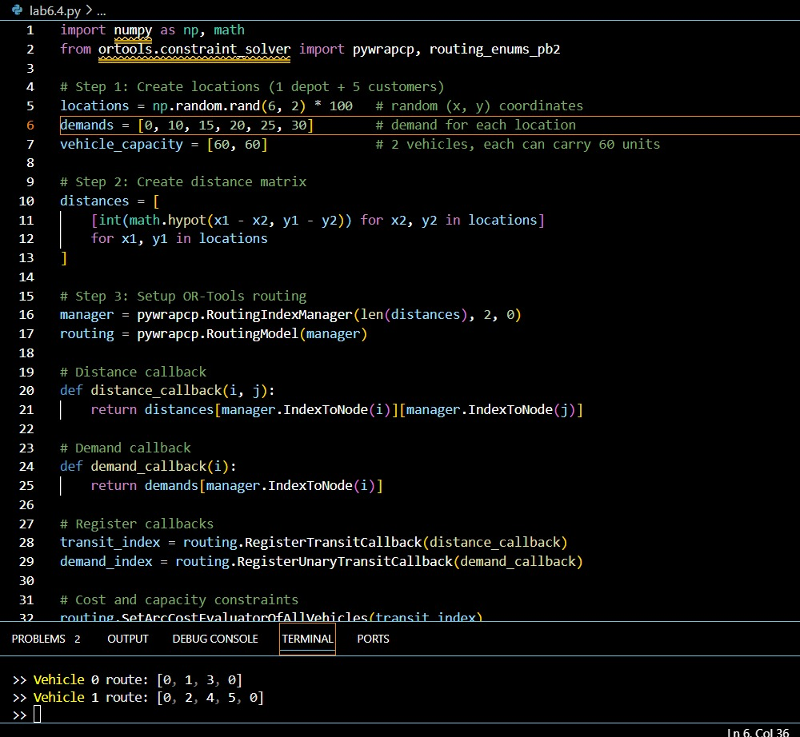
Observation
The program optimizes delivery routes using AI-assisted algorithms. It assigns customers to vehicles efficiently, ensuring each vehicle’s load stays within capacity and total distance is minimized. Routes vary each time due to random locations.

Q2:
Scenario: In the domain of Finance, a company is facing a challenge related to data
structures with ai.
Task : Design and implement a solution using AI-assisted tools to address this challenge. Include code, explanation of AI integration, and test results.
Deliverables: Source code, explanation, and output screenshots

Prompt :
Detect unusual or suspicious transactions using AI tools. Use data structures like arrays or data frames to store and process financial data. Apply an AI model to find anomalies and show results with code, explanation, and output.

CODE : 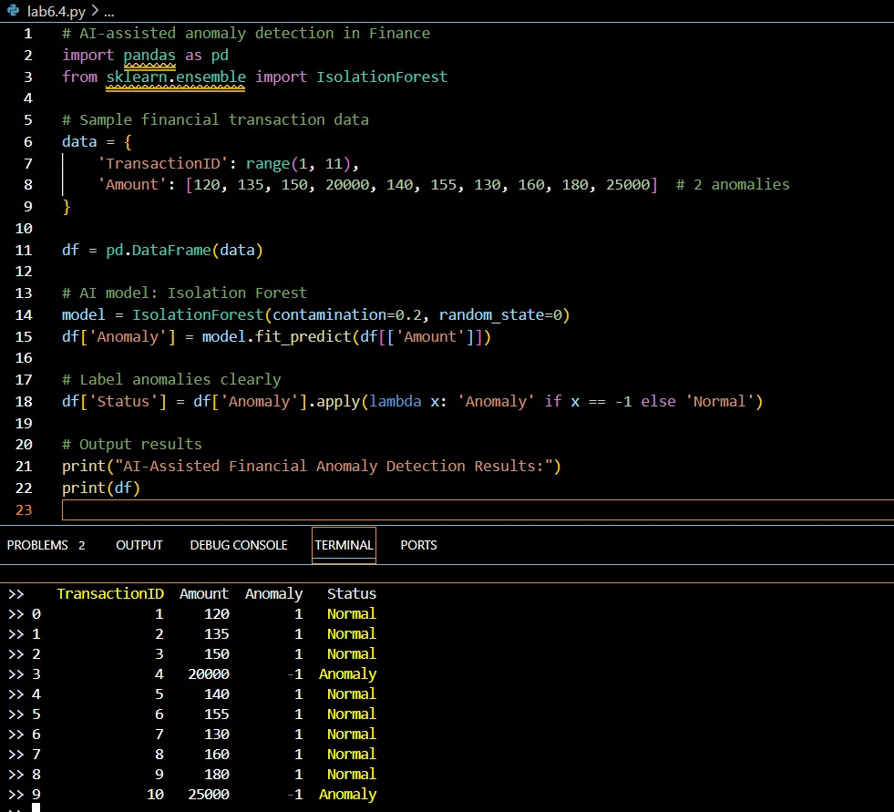

Observation:
Converted nested financial data structures (customers → accounts → transactions) into a structured tabular form suitable for modelling.
Trained a predictive model to estimate risk scores based on transaction-level features.
Re-integrated predictions back into the original nested data structure so that account objects now carry their predicted risk.
Achieved a high R² (≈ 0.95 in this simulation) indicating good fit on this synthetic data.

